**PROJECT REPORT ON**

**STUDENT RESULT MANAGEMENT SYSTEM**

**SUBMITTED BY**

**M. Manisha (AP18110010402)**

**Contents**

1. Abstract
2. Objective
3. Work flow
4. Student result management system distribution module
5. Admin
6. Student classes
7. Subject
8. Students
9. Result
10. Database design
11. Proposed system
12. Benefits
13. Diagrams

1.1 - use case diagram

1.2 - class diagram

1.3 - state-chart diagram

1.4 - sequence diagram

1.5 - component diagram

1. Data flow diagrams

2.1 - 0 - level data diagram

2.2 - admin data flow diagram

2.3 - student classes’ data flow diagram

2.4 - subject data flow diagram

2.5 - student’s data flow diagram

2.6 - result data flow diagram

1. Limitations
2. Future enhancements
3. conclusion
4. references

**ABSTRACT:**

The main objective of this project is to provide the examination results to the students in simple way. This project is of benefit to students and Institutions for a simple way of getting the results online. In this project, we have developed student result management website which would be responsive by using HTML, CSS and JavaScript as front end tools whereas background is managed by database (MySQL) by connecting to apache server. This application tool is for showing the subject status and the result in a secure way.

This project includes three modules of the register / login module, the admin module and the student module. The admin module is used to build and manage the subjects, classes and add the students and their performance.

Also, this application leads to secure reliable, error free and fast management system. This also maintains computerized records and the data can be stored for a longer period with easy accessing.

This system is meant for the students. And the privileges offers the student to read and perform his / her results by providing them their username and password for secure login and also the new student Registration is also available.

The entire result analyzer would be under the control of the admin and the admin has maximum rights for processing, writing and executing the report. Then admin gives all the rights to the teacher, student to access the result. Then the student can share his / her result and can download.

**OBJECTIVE:**

The main objective of this project is to manage the details of progress and to provide the examination results to the students in simple way. This project is of benefit to students and Institutions for a simple way of getting the results online. This application tool is for showing the subject status and the result in a secure way. This application is totally in the control of administrator and only he can only access. The main purpose of this project is to build an application that reduces manual work to track the details of student and for managing all the information like result, progress of the student etc.

**Student Result Management system is divided in three modules**

* Register/login module
* Student module
* Admin module

**Register/login module**

* The "STUDENT RESULT MANAGEMENT SYSTEM"

Webpage.

* It consists of two portals Student and Admin.
* To login to the portal, using login tab.

**Admin Features**

* Admin can add/update- Class
* Admin can add/update- Subjects
* Admin can add/update Subject combination with class.
* Admin can register a new student and also edit information of the student.
* Admin can declare/ edit the result of a student.
* Admin can change the password

**Students**

* Student can search their result using their Roll Numbers.
* Student can download their result.

**WORK FLOW:**

Designing is the first step in the development phase for any techniques and principles that are intended to define a device, processor system in sufficient detail to allow its physical realization.

If the software specifications have been evaluated and the software design has been specified, three technical activities-design, coding, implementation, and testing are needed to construct and validate the software.

**ADMIN:**

The admin login page is the first page of our website where we need to first sign in to our website by providing our details like email Id and password. The admin change password page is used to change the password in case you forgot it. To change password it requires the current password of the page and new password that you wants to set up.

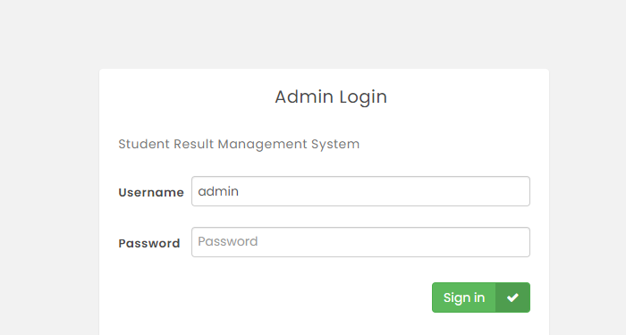

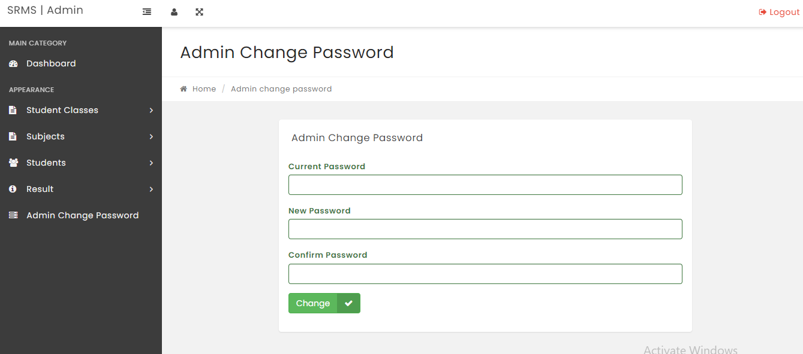

**STUDENT CLASSES:**

It is used to create and manage class.The create class is to enter your class details at first the class name ex: third, fourth etc.; then class name in numeric and at last the section that student belongs to. Ex: 3-A, 4-A etc. Manage class is to enter all the different classes in the institution ex: third, Fourth- etc.; then the numerical of each class and the section name of each class.

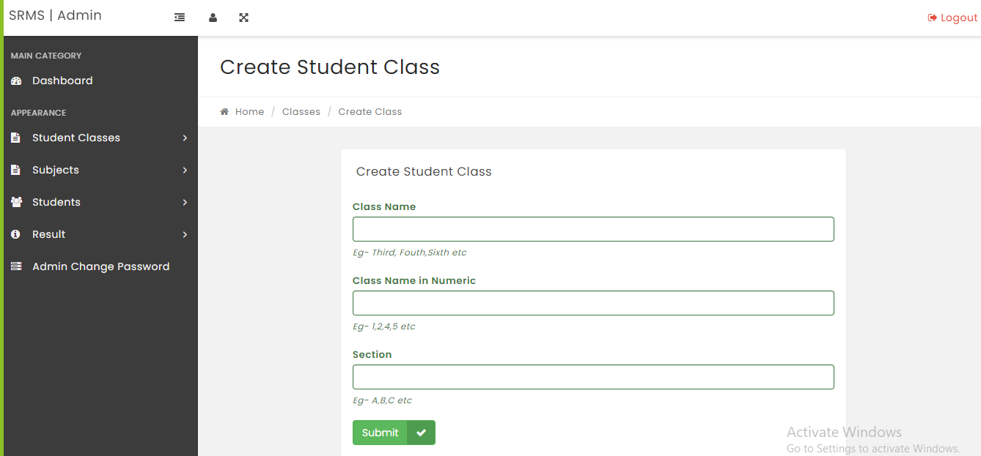

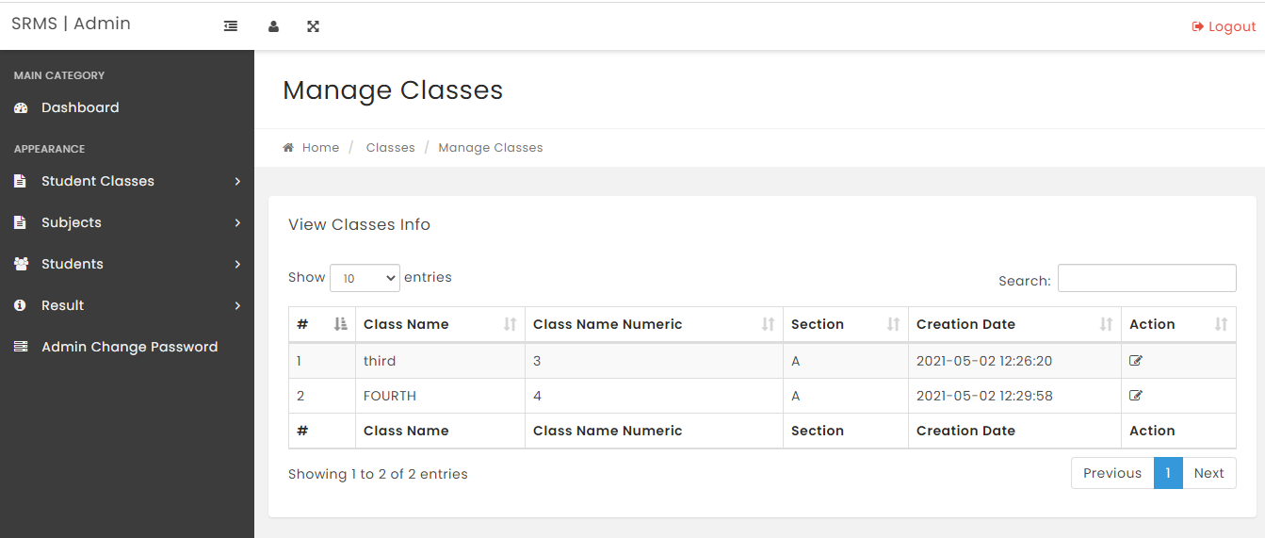

**SUBJECT:**

It is used to create and manage subjects. To create subject, we enter subject name and subject code. Manage subjects consists of different subject names that institution consists.

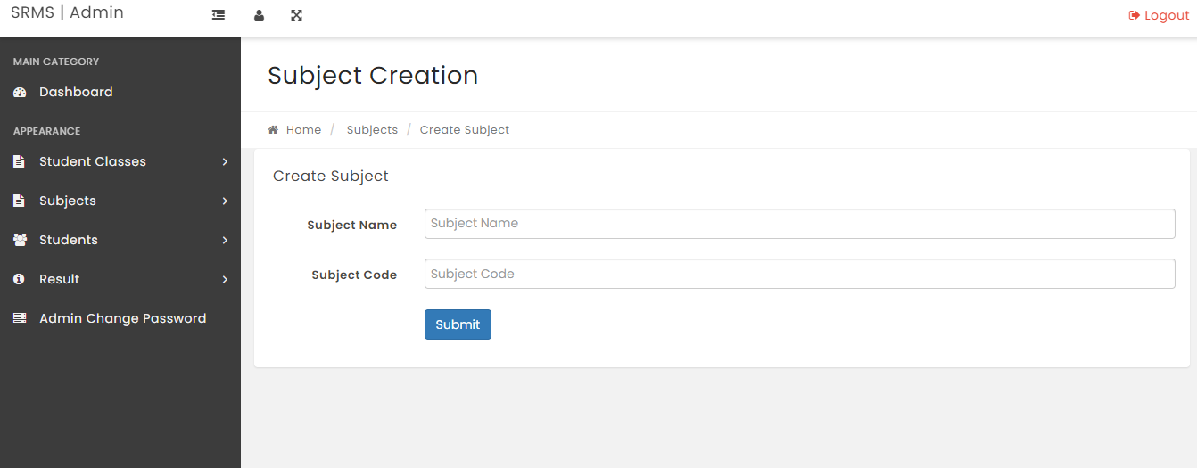

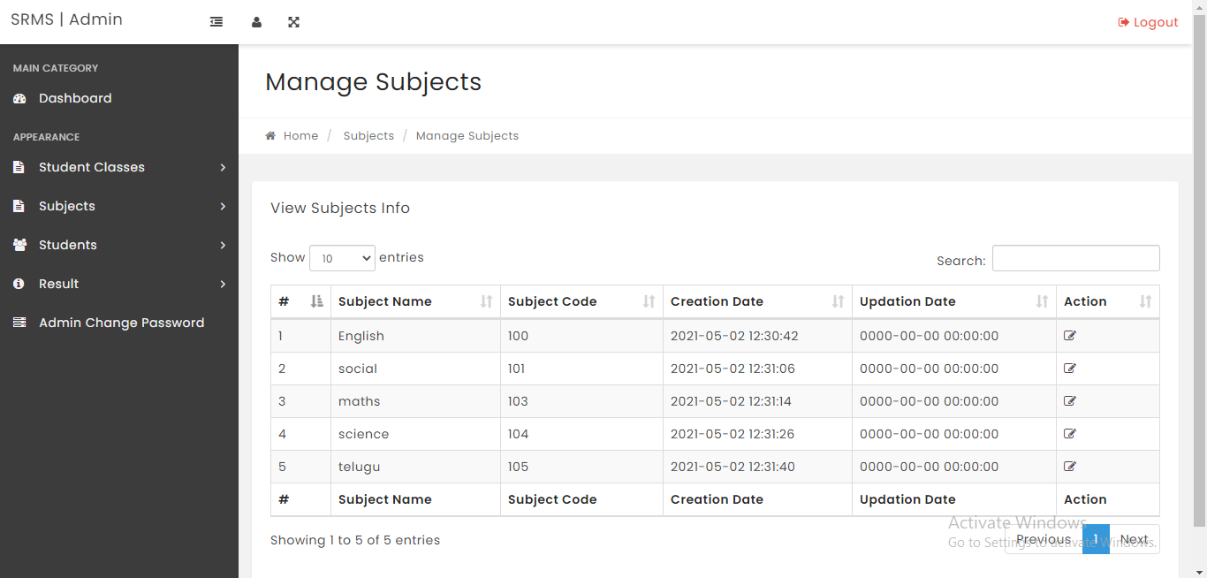

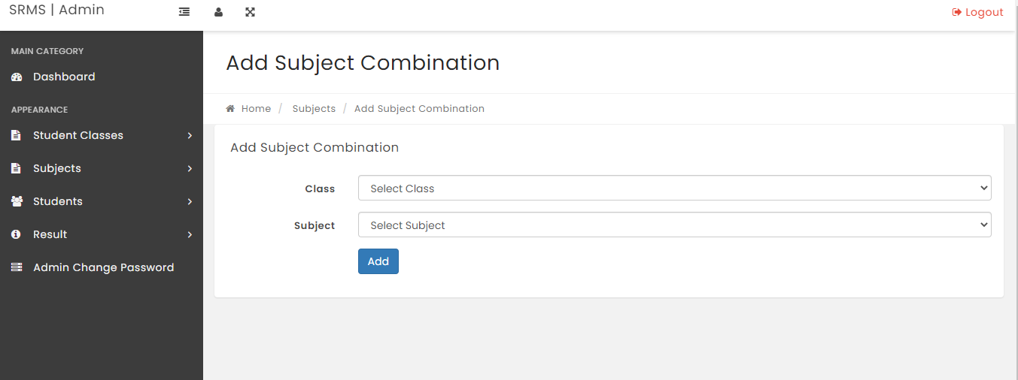

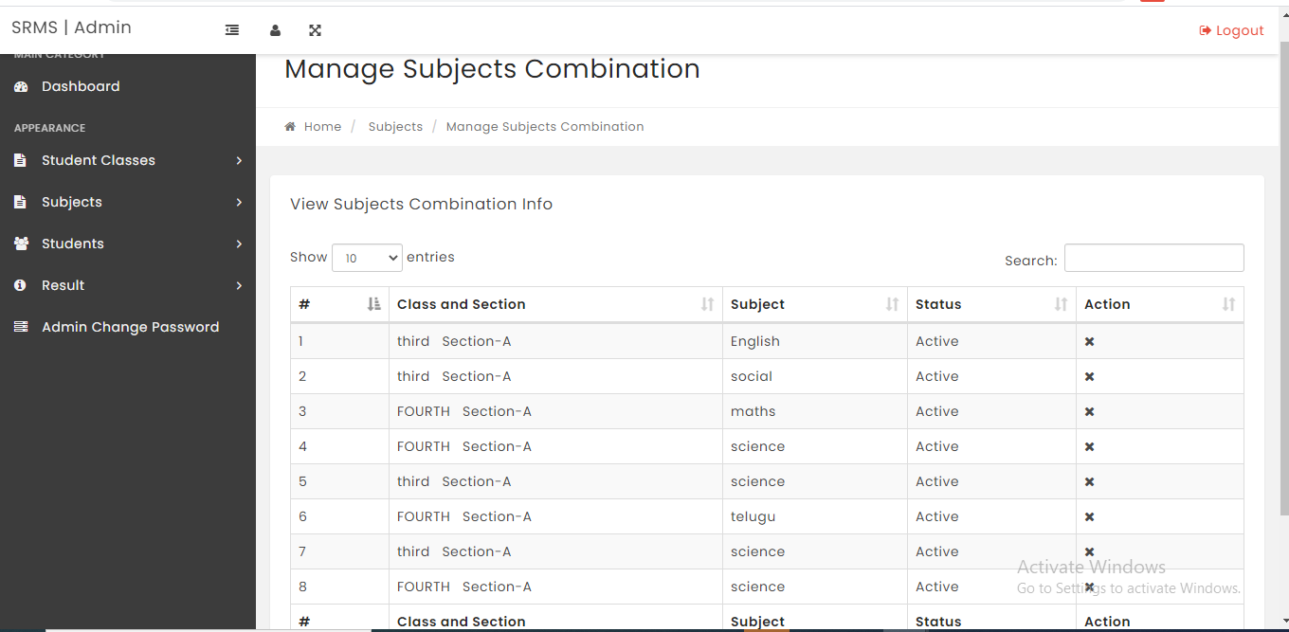

**STUDENTS:** It is used to add and manage students. Add students are the place where you can add the students and details. The student admission page is used to add the student data by entering details like Full name of the student, Registration number, email ID of student, gender, class he wants to join in and finally Date of birth of a student. Manage students views the students information like student name, Registration no, the class he or she joined. It makes easy to find the student information.

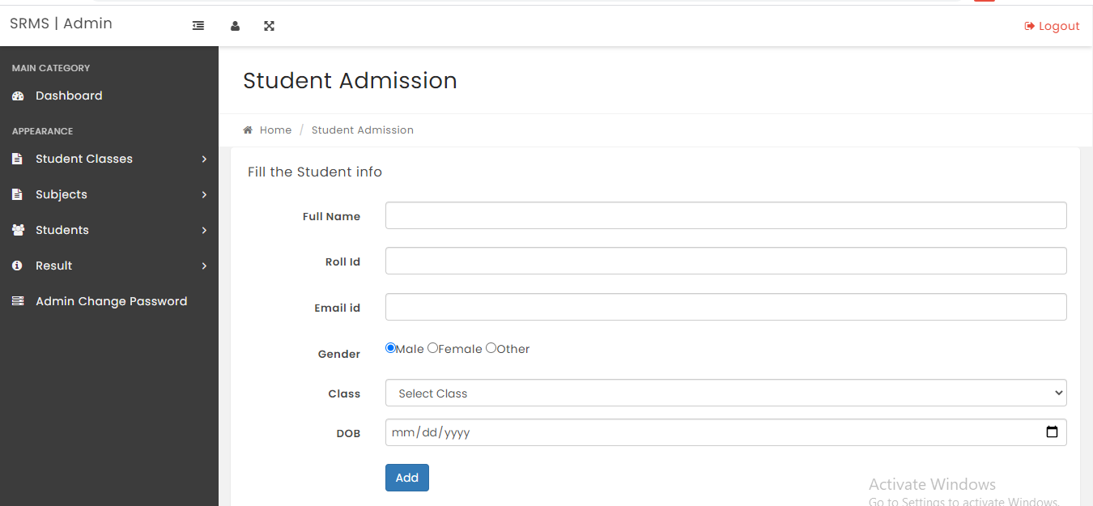

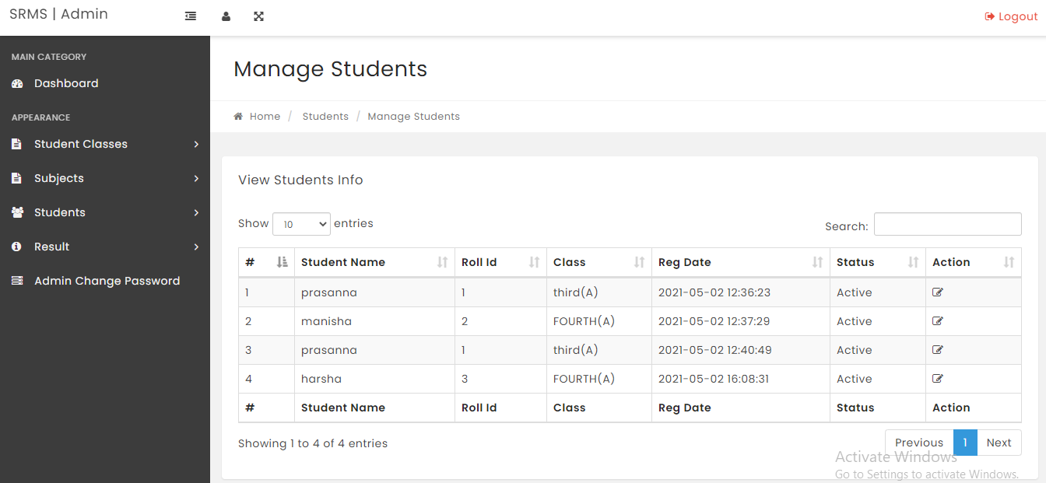

**RESULT:**

It is used to add and manage results. The declare result page is the final page of our website where you get the result. The management has right to add the results of a students. It consists of class name, student name and different subjects with the marks student obtained in a particular subject. After declaration the results student can see the results he or she obtained in each subject. It consists of name of student, roll no, and student's class name and finally the overall percentage of the student on the basis total marks.

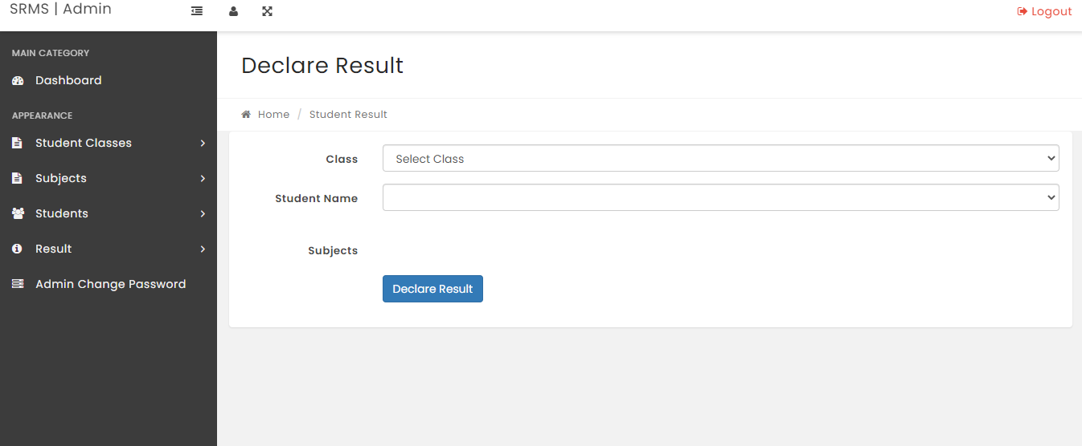

**For opening the results by the students interface is shown in the below picture**

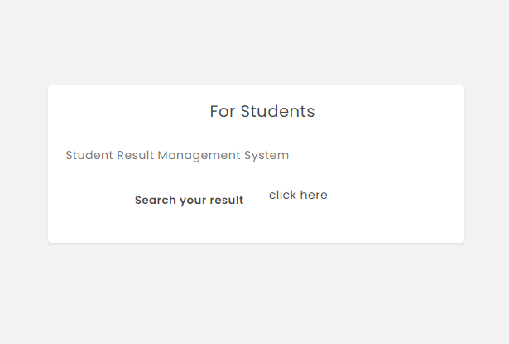

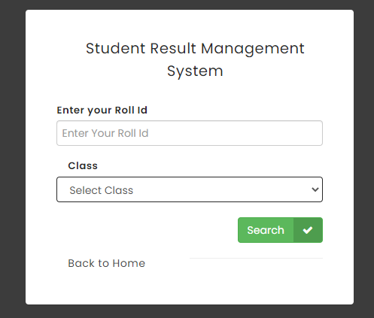

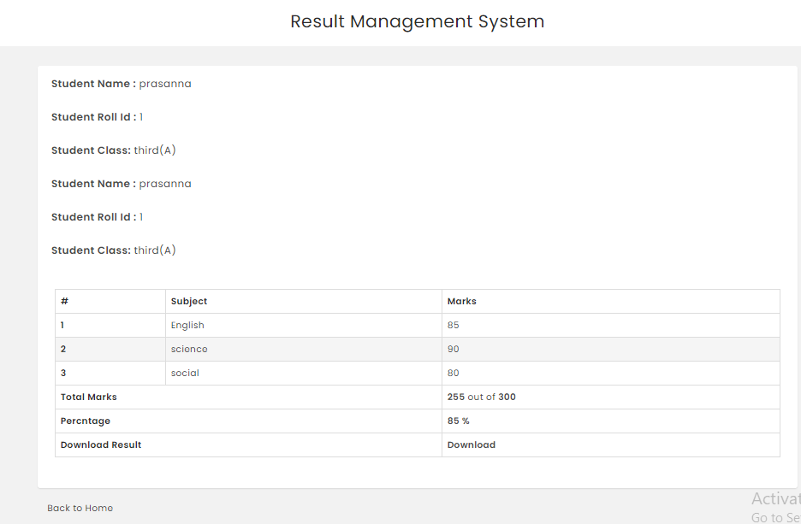

**DATABASE DESIGN:**

This system is designed to handle processes such as input scores efficiently, storing results automatically, and interpreting the overall student result. The usual manual process has now reached a level where coping with the magnitude of examination work in the given time, is difficult for the available man power. Imbalance between the availability of manpower and the amount of work to be done in the review process leads to delay in declaring the results of the examination.

Consequently, the introduction of computerization is an effective measure which can improve the efficiency of the examination result processing, especially with the use of software for the examination result processing.Computerized database systems such as the Microsoft SQL server, MySQL etc. have been built to minimize redundancy of data.

The data has to be stored in the system and retrieved from the database. Database design is an integral part of system design. They are organized and put together to build the framework for storing and retrieving data. The ultimate aim is to make the user's access to the database simple, quick, inexpensive and scalable. The XAMPP and MySQL Access framework was chosen for the development of the related databases in this project.

**PROPOSED SYSTEM:**

"STUDENT RESULT MANAGEMENT SYSTEM" is proposed to replace the administration's manual work.

This application allows students to easily access the modules such as student results and other information required for students courses.

This program is versatile and student-friendly.

And the amount of time taken to get the details of results and other information will be reduced.

**BENFITS:**

* Manage the student’s results and keep a record of the student results throughout the year.
* You can enter student scores, and this will automate the school report card generation.
* Eco-friendly: You can avoid paperwork
* Effective Student Data Management
* Supervise student success

**DIAGRAMS**

**1.1: Use case diagram**

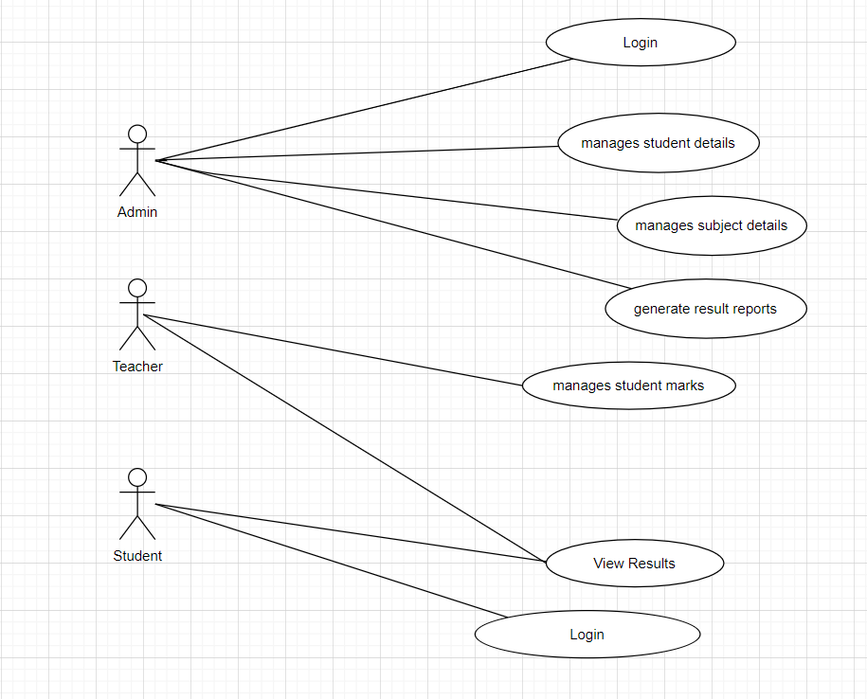

**1.2: Class diagram**

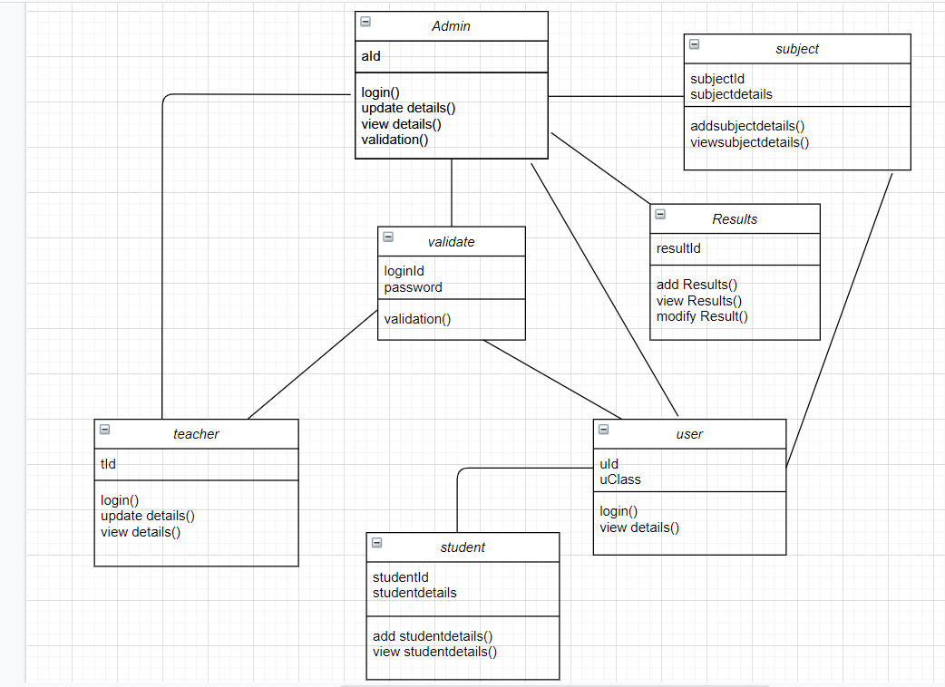

**1.3: State-chart diagram**

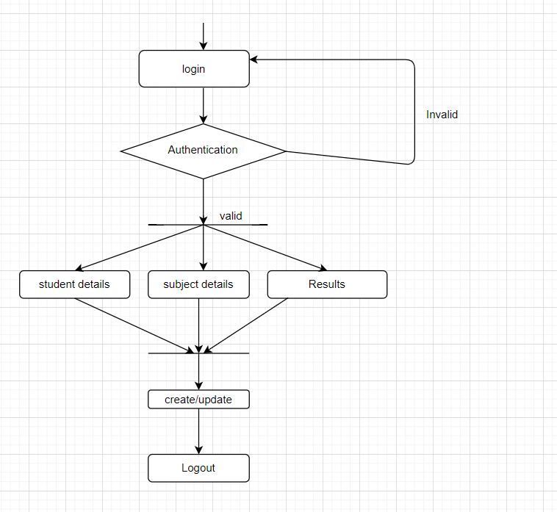

**1.4: Sequence diagram**

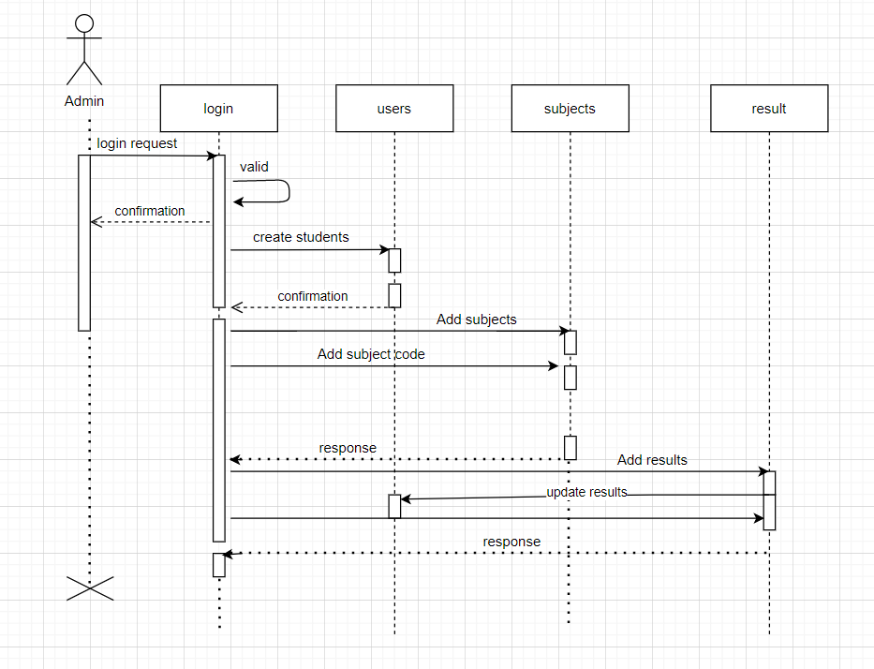

**1.5: Component diagram**

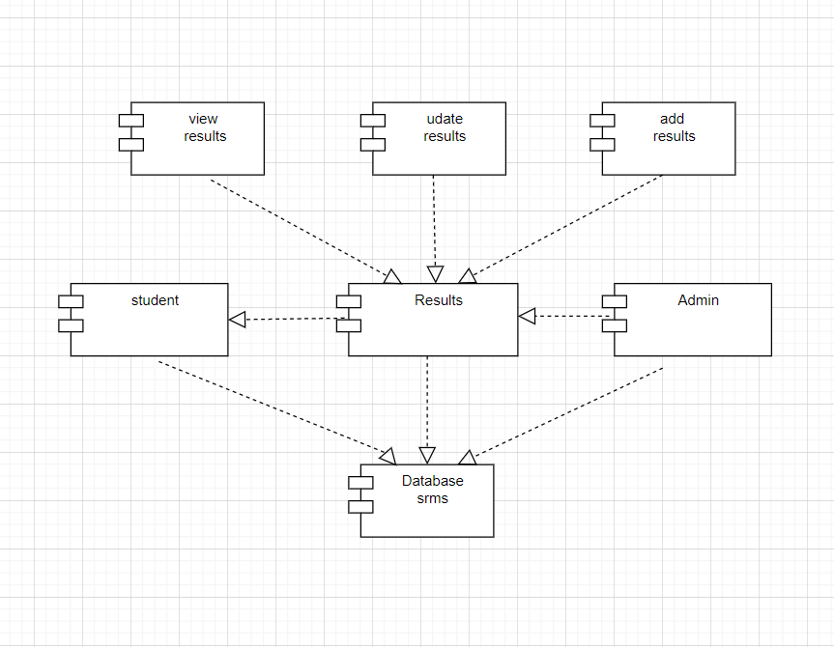

**Data flow diagrams**

**2.1: 0 level data flow diagram**

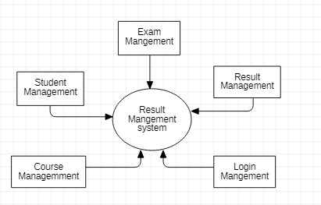

**2.2 : Admin data flow diagram**

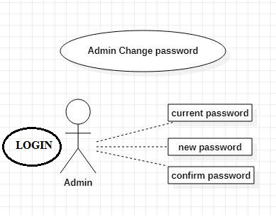

**2.3: Student classes’ data flow diagram**

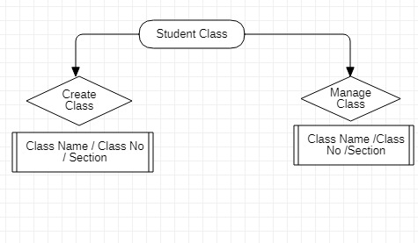

**2.4: Subject data flow diagram**

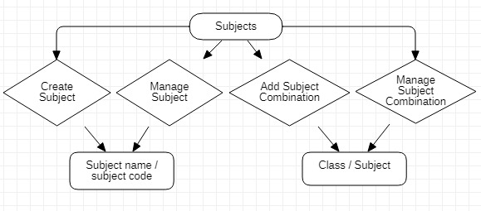

**2.5: Student data flow diagram**

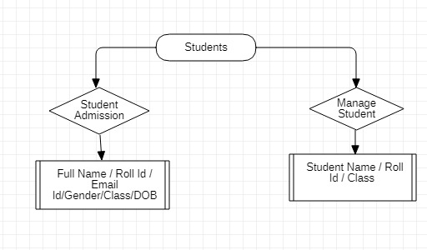

**2.6: Result data flow diagram**

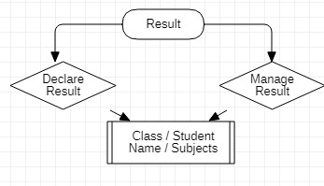

**GOALS:**

* The main goal of this project is to simplify the process of information management in any institution.
* It helps the management to maintain the information about students, marks, department details etc. Thus it helps the management to maintain the records in a systematic order and also to access details very quickly.
* This can be implemented in all educational institutions to proceed the office works smoothly.
* Thus we can retrieve any details regarding student, staff, exams etc. within a short interval of the time. So that we can make administers task very easy as well as fast.
* This entire system is managed by a system administrator, who has complete system power, to read, write and executes the results, and grants access to teachers and students. And the teachers have the privilege of assigning the marks of the students, through which automatically a result will be generated and each student will only have access to their results using their respective account.

**BENFITS:**

* Manage the student’s results and keep a record of the student results throughout the year.
* You can enter student scores, and this will automate the school report card generation.
* Eco-friendly: You can avoid paperwork
* Effective Student Data Management
* Supervise student success

**LIMITATIONS:**

There are not many disadvantages in the System. They can be counted on fingers.

* This app can only be used by people who are accustomed to normal Smartphone or computer use.
* Extensive modules and enhancements make it difficult to use for a user.
* Many of these disadvantages can be avoided by selecting the correct, cost-effective and best applications.

**FUTURE ENHANCEMENTS:**

Though our project is itself matured enough but still betterment is always an open door. In this case, also we can add some features to this project in future to make this software more reliable. Such as

* Filtering the students based on their result.
* Automatic Generation of report card along with grades, based on grade calculation easily.
* Providing the certificate view.
* Modify the project with more graphics with better approach
* There is a future scope of this facility that can add to many more features such as group chat where students can discuss various issues, thus making it more user-friendly interactive that meets each user's needs in the best possible way.

**CONCLUSION:**

The STUDENT RESULT MANAGEMENT SYSTEM is developed using Front end-html, css, JavaScript and backend-My SQL.

This system allows whole process online where there will be ease of work, World Wide publishing, ease of data storage, Result can be accessed from anywhere in the world, Better data flow output. No Loss of Data.

And finalizing the system design with the development of a friendly device user interface. The framework implementation was facilitated by the use of the Java EE platform. Eclipse IDE was an important resource for designing the framework, and some technologies such as Apache Tomcat, Java programming language, MySQL DBMS, HTML, CSS, and JavaScript.

This software was designed in such a way that potential improvements can be made easy. One can deduce the following conclusions from the development of the project.

* Complete system automation improves efficiency.
* It gives the approved users sufficient access, depending on their permissions
* It effectively overcomes the Communications delay. Updating Information becomes much easier.
* The system shall have sufficient scope for future modifications if

necessary.

**REFERENCES:**

1. <https://codecreator.org/>
2. <https://www.w3schools.com/>
3. https://www.javaguides.net/
4. [https://phpgurukul.com/](https://phpgurukul.com/php-projects-free-downloads/)
5. Godbole, A. S., & Kahate, A. (2003). Web technologies: TCP/IP to Internet application architectures. New Delhi: Tata McGraw-Hill.